Russian Academy of Sciences
A.N. Severtsov Institute of Ecology and Evolution, Russian Academy of Sciences

N.P. Laverov Federal Research Center for Complex Studies of the Arctic,
Russian Academy of Sciences

Zoological Institute, Russian Academy of Sciences

 | 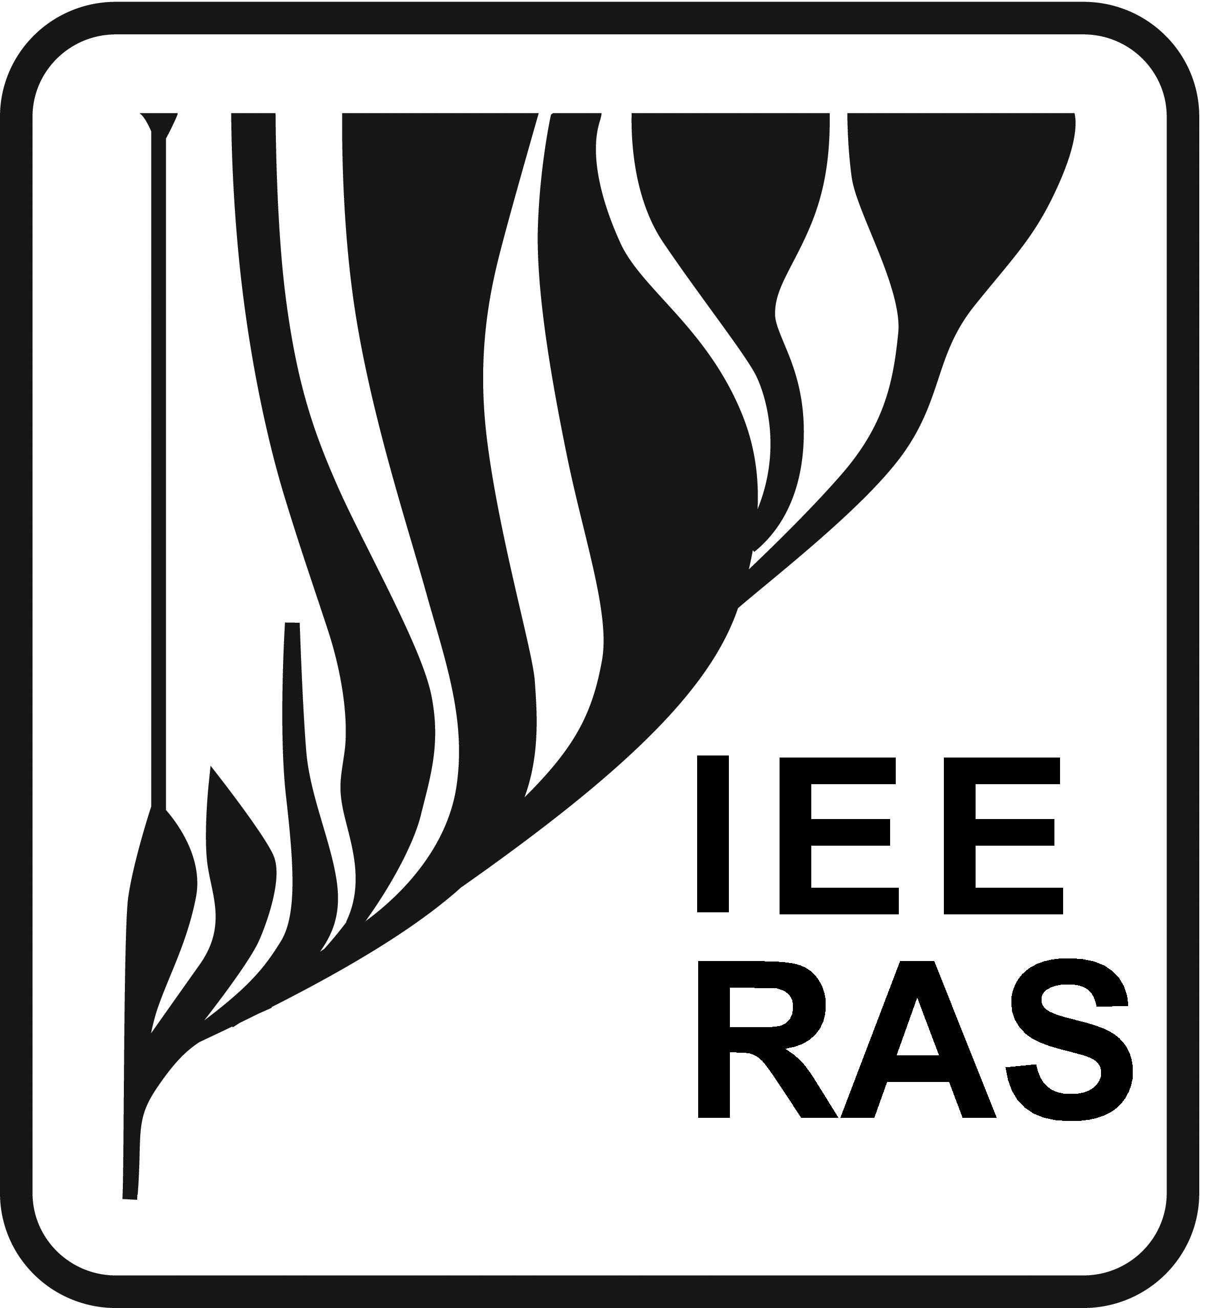 | 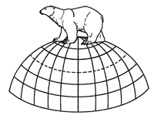 | 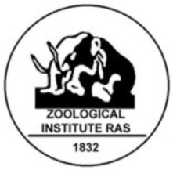

Wildlife of the Arctic:
Biodiversity Conservation and Ecosystems State Assessment
International Conference
October 30 – November 3, 2017, Arkhangelsk, Russia

Dear Colleagues,
We invite you to participate in the International Conference Wildlife of the Arctic: Biodiversity Conservation and Ecosystems State Assessment, dedicated to the Year of Ecology (Russia).
The Conference will be held October 30 – November 3, 2017 in Arkhangelsk, Russia.
The conference is organized in collaboration with the Scientific Council of the Russian Academy of Sciences on Biological Systems Ecology, Scientific Council of the Russian Academy of Sciences on Hydrobiology and Ichthyology, Commission of the Russian Academy of Sciences on Biodiversity Conservation and the Theriological Society of the Russian Academy of Sciences.

Working languages of the conference: Russian, English.

Participation form: oral or poster presentation.

The proceedings of the Conference will be published in a volume included in the Russian Science Citation Index.

The Organizing Committee should be informed in case you need to receive a formal invitation to participate in the conference.

Organizing Committee:
Rozhnov Viatcheslav Vladimirovich, academician of the Russian Academy of Sciences, doctor of biology, A.N. Severtsov Institute of Ecology and Evolution, Russian Academy of Sciences, director, Moscow (Chair).
Pavlenko Vladimir Ilyich, doctor of economic, N.P. Laverov Federal Research Center for Complex Studies of the Arctic, director, Arkhangelsk (Co-chair).
Pavlov Dmitry Sergeevich, academician of the Russian Academy of Sciences, doctor of biology, A.N. Severtsov Institute of Ecology and Evolution, Russian Academy of Sciences, scientific supervisor, Moscow (Co-chair)

Pugachev Oleg Nikolaevich, academician of the Russian Academy of Sciences, doctor of biology, Zoological Institute, Russian Academy of Sciences, director, St. Petersburg (Co-chair).
Mordvintsev Ilya Nikolaevich, PhD, A.N. Severtsov Institute of Ecology and Evolution, Russian Academy of Sciences, Cabinet for Methods of Remote Sensing of Earth Using in Ecology, head, Moscow (Executive secretary).
Antonevich Anastasia Lvovna, PhD, A.N. Severtsov Institute of Ecology and Evolution, Russian Academy of Sciences, senior scientist, Moscow (Scientific coordinator).
Denisenko Stanislav Georgievich, doctor of biology, Zoological Institute, Russian Academy of Sciences, Marine Research Laboratory, head, St. Peterburg.
Ivanov Evgeny Aleksandrovich, PhD, A.N. Severtsov Institute of Ecology and Evolution, Russian Academy of Sciences, research scientist, Moscow.
Makarova Olga Lvovna, PhD, A.N. Severtsov Institute of Ecology and Evolution, Russian Academy of Sciences, Synecology Laboratory, head, Moscow.
Naidenko Sergey Valerievich, doctor of biology, A.N. Severtsov Institute of Ecology and Evolution, Russian Academy of Sciences, deputy director, Moscow.
Novoselov Aleksandr Pavlovich, doctor of biology, N.P. Laverov Federal Research Center for Complex Studies of the Arctic, Russian Academy of Sciences, senior scientist, Arkhangelsk.
Platonov Nikita Gennadievich, PhD, A.N. Severtsov Institute of Ecology and Evolution, Russian Academy of Sciences, senior scientist, Moscow.
Rozenfeld Sofia Borisovna, PhD, A.N. Severtsov Institute of Ecology and Evolution, Russian Academy of Sciences, senior scientist, Moscow.
Semushin Andrey Vladimirovich, PhD, Polar Research Institute of Marine Fisheries and Oceanography, deputy director, Murmansk (PINRO).
Sukhotin Alexey Aleksandrovich, PhD, Zoological Institute of the Russian Academy of Sciences, White Sea Biological Station, director, St. Petersburg.

The Conference will cover the following subjects:
- Species diversity and degree of knowledge of the principal groups of organisms in the Arctic.
- Assessment of the arctic ecosystems state, including using high technology methods.
- Arctic ecosystems functioning under climate changes and anthropogenic pressure.
- Paleo-ecological studies as the basis for predicting possible changes in arctic ecosystems.
- Scientific approaches to regulation of economical activities in the Arctic.
- Role of protected areas in conservation of key species and ecosystems.
- Approaches to developing of the Biological Diversity Monitoring System in the Russian Arctic.

The following round tables are planned:
- Realization of Biodiversity Conservation Strategy, choice of flag species for nature managers.
- Responsibility of business in biodiversity conservation of the Arctic.
- State management of natural resources (with the participation of the Ministry of Natural Resources and Environment of the Russian Federation and the Federal Service for the Supervision of Natural Resources).
- Potential protected marine areas and economical activities in the Arctic.
- New technologies in the study of the wildlife of the Arctic.

Further information on the Conference and the program of the Conference will be e-mailed in the second information letter.

Contact information:

A.N. Severtsov Institute of Ecology and Evolution, Russian Academy of Sciences
33, Leninsky prosp., Moscow, 119071
Phone: +7-926-708-78-41
E-mail: noo.ipee@gmail.com, ilia.mordvintsev@gmail.com

The Organizing Committee will be grateful for distributing this letter among potential participants of the Conference.

