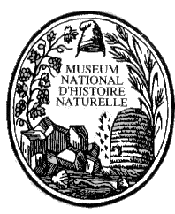

S
F
E
P
M

VI European Congress of Mammalogy

Muséum National d’Histoire Naturelle

Jardin des Plantes, Paris, France

19-23 July 2011

FIRST CALL

The MNHN, INRA, CNRS, SFEPM, and the European Society of Mammalogy are very pleased to announce you that the next meeting will be hold in the heart of Paris in the Historical Botanical Garden.
The aim of the conference will be to gather all forces of European Mammalogy and to update our knowledge into Taxonomy, Phylogeny, Evolution, Ecology, Biogeography, Conservation of Mammals. Post-conference excursions will be organized in the Parc de la Haute Touche and Baie de Somme.

Christiane Denys and Stéphane Aulagnier (organizors)

Please fill the form and send it back before 15th September 2010 to
Christiane Denys (denys@mnhn.fr)
VI European Congress of Mammalogy

Muséum National d’Histoire Naturelle

Jardin des Plantes, Paris, France

19-23 July 2011

NAME _____________________________________________________________

FIRST NAME ________________________________________________________

ADDRESS __________________________________________________________

E-MAIL _____________________________________________________________

I intend to present:

________ an oral communication

________ a poster

Provisional title:

___________________________________________________________________

I wish to organize a session on the following topic:
(give a title, a short summary of the importance of the subject and a justification why you want to organize this session (1 page maxi), the potential number of participants, the name and mail address of a speaker you would like to invite)

___________________________________________________________________

